Coronary arteries hold heart-regenerating cells

August 20, 2014

Vanderbilt University Medical Center

Endothelial cells residing in the coronary arteries can function as cardiac stem cells to produce new heart muscle tissue, investigators have discovered. The heart has long been considered to be an organ without regenerative potential, said one expert. Recent findings, however, have demonstrated that new heart muscle cells are generated at a low rate, suggesting the presence of cardiac stem cells. The source of these cells was unknown.

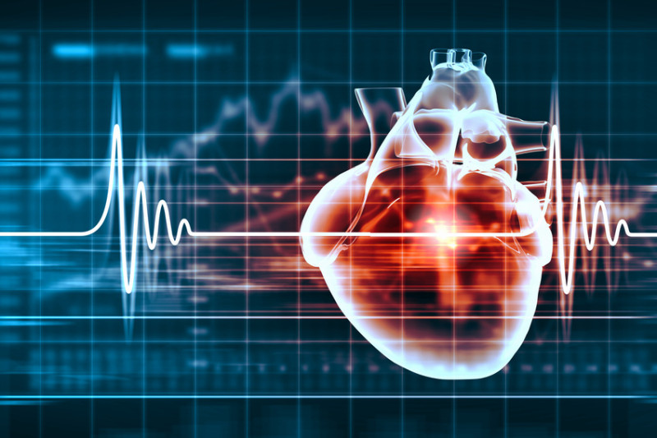
"People thought that the same heart you had as a young child, you had as an old man or woman as well," said Antonis Hatzopoulos, Ph.D. Recent findings, however, have demonstrated that new heart muscle cells are generated at a low rate, suggesting the presence of cardiac stem cells.
Credit: © Sergey Nivens / Fotolia
[Click to enlarge image]
Endothelial cells residing in the coronary arteries can function as cardiac stem cells to produce new heart muscle tissue, Vanderbilt University investigators have discovered.
The findings, published recently in Cell Reports, offer insights into how the heart maintains itself and could lead to new strategies for repairing the heart when it fails after a heart attack.
The heart has long been considered to be an organ without regenerative potential, said Antonis Hatzopoulos, Ph.D., associate professor of Medicine and Cell and Developmental Biology.
"People thought that the same heart you had as a young child, you had as an old man or woman as well," he said.
Recent findings, however, have demonstrated that new heart muscle cells are generated at a low rate, suggesting the presence of cardiac stem cells. The source of these cells was unknown.
Hatzopoulos and colleagues postulated that the endothelial cells that line blood vessels might have the potential to generate new heart cells. They knew that endothelial cells give rise to other cell types, including blood cells, during development.
Now, using sophisticated technologies to "track" cells in a mouse model, they have demonstrated that endothelial cells in the coronary arteries generate new cardiac muscle cells in healthy hearts. They found two populations of cardiac stem cells in the coronary arteries -- a quiescent population in the media layer and a proliferative population in the adventitia (outer) layer.
The finding that coronary arteries house a cardiac stem cell "niche" has interesting implications, Hatzopoulos said. Coronary artery disease -- the No. 1 killer in the United States -- would impact this niche.
"Our study suggests that coronary artery disease could lead to heart failure not only by blocking the arteries and causing heart attacks, but also by affecting the way the heart is maintained and regenerated," he said.
The current research follows a previous study in which Hatzopoulos and colleagues demonstrated that after a heart attack, endothelial cells give rise to the fibroblasts that generate scar tissue.
"It looks like the same endothelial system generates myocytes (muscle cells) during homeostasis and then switches to generate scar tissue after a myocardial infarction. After injury, regeneration turns to fibrosis," he said.
Understanding this switch could lead to new strategies for restoring regeneration and producing new heart muscle after a heart attack, during aging or in disease conditions such as diabetes and high blood pressure, he said.
"If we can understand the molecular mechanisms that regulate the fate switch that happens after injury, perhaps we can use some sort of chemical or drug to restore regeneration and make muscle instead of scar," Hatzopoulos said. "We think there is an opportunity here to improve the way we treat people who come into the clinic after myocardial infarction."

Story Source:
The above story is based on materials provided by Vanderbilt University Medical Center. Note: Materials may be edited for content and length.

Journal Reference:
- Bryan A. Fioret, Jeremy D. Heimfeld, David T. Paik, Antonis K. Hatzopoulos.Endothelial Cells Contribute to Generation of Adult Ventricular Myocytes during Cardiac Homeostasis. Cell Reports, 2014; 8 (1): 229 DOI:10.1016/j.celrep.2014.06.004

